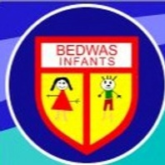

Bedwas Infants School
Information Regarding the Pupil Development Grant 2024 – 2025

- The total number of pupils on roll for September 2024 is: 129
- The schools FSM population is approx. 17%
- The total allocation of PDG to this school is £28,750

The school undertakes the following work and activities in order to support pupils facing the challenges of poverty and deprivation: -

- Targeted small group and 1:1 interventions for vulnerable pupils;
- THRIVE & ELSA support for pupils in Foundation Phase to deliver emotional, social and behavioural support for identified FSM pupils as well as for pupils in previous years who have been eligible for FSM.
- Elklan support is provided for identified FSM pupils in Nursery to support speech and language development.
- Phonological Awareness support for identified pupils in Year 1 and 2.
- Deployment and funding for support practitioners to provide the interventions noted above.



