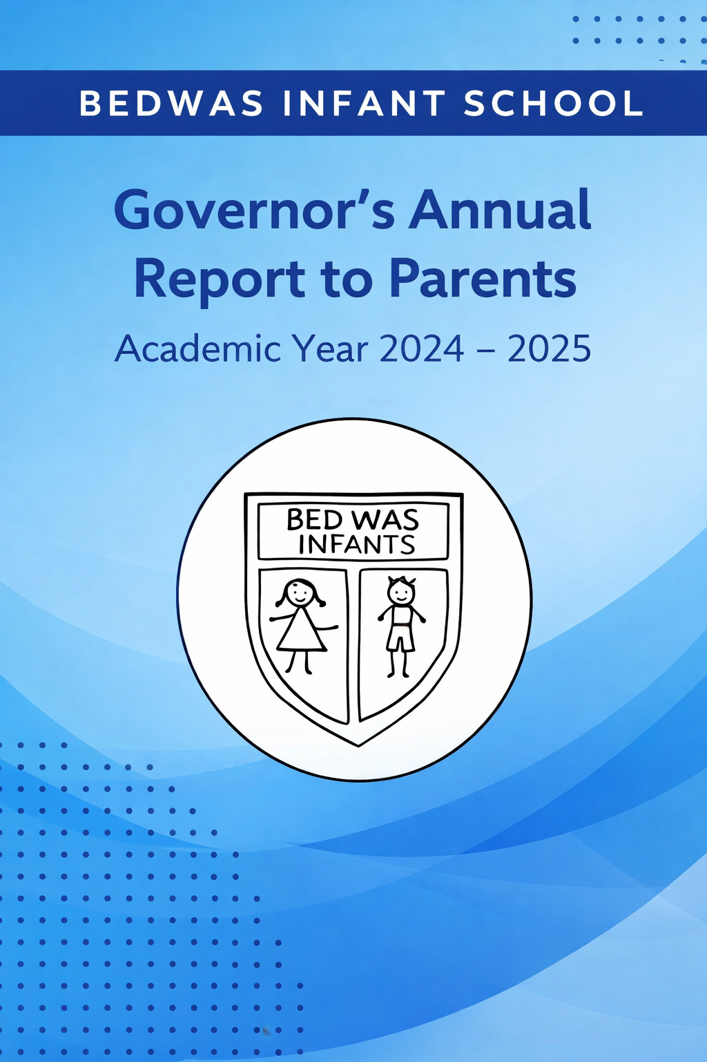

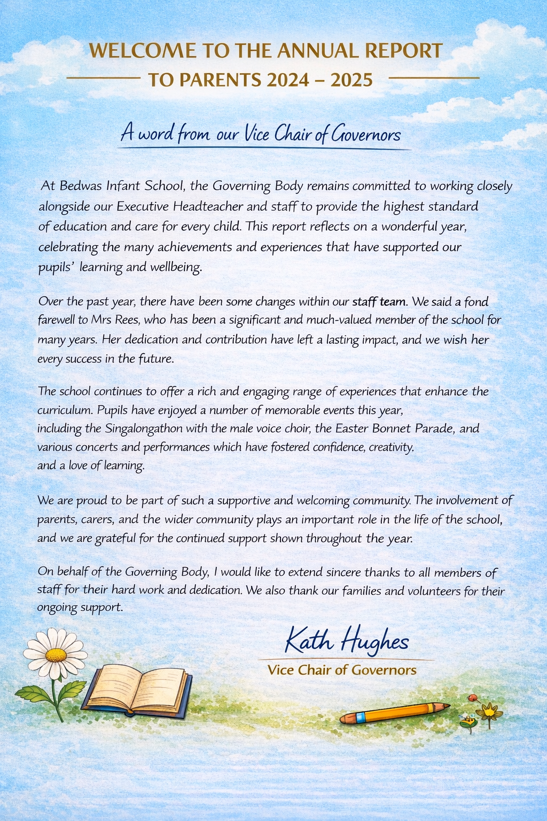

Who’s Who on the Governing Body
Governor Type | Name
Community Gov apptd by GB/Cymunedol, penodwyd gan BLI | Kath Hughes
Community Gov apptd by GB/Cymunedol, penodwyd gan BLI | Sarah  Armstrong
Community Gov apptd by GB/Cymunedol, penodwyd gan BLI | Claire Tidy
Headteacher/Pennaeth | Victoria Jenkins Delf
LA Appointed/Penodwyd gan yr ALI | Elizabeth M Aldworth
LA Appointed/Penodwyd gan yr ALI | Tina Elms
LA Appointed/Penodwyd gan yr ALI | Vacancy
Minor Authority/Man Awdurdod | Vacancy
Parent Representative/Cynrychiolydd Rhiant | Ceri Bracegirdle
Parent Representative/Cynrychiolydd Rhiant | Lloyd  Bowen
Parent Representative/Cynrychiolydd Rhiant | Steve Collins
Parent Representative/Cynrychiolydd Rhiant | Vacancy
Teacher Representative/Cynrychiolydd Athrawon | Angela Cartwright
Staff Representative/Cynrychiolydd Staff | Tracy Hayward

Parent Governor Vacancies
When a vacancy arises on the Governing Body for a parent representative, the Local Authority and the school will notify all parents of the vacancy and make the necessary arrangements for the election.
Every parent of a registered pupil at the school is entitled to stand as a candidate and vote in the election. Each parent will receive a letter and a nomination form sent via their child. The completed nomination form, along with a personal statement, must be returned to the school by the specified deadline.
If more than one nomination is received, the election will be conducted by ballot.

Link Governors
Governors have been assigned specific responsibilities to support key areas of school improvement:
Area of Responsibility | Governor
Child Protection / Safeguarding | T Elms
Looked After Children (CLA) | K Hughes
Additional Learning Needs (ALN) | C Bracegirdle
Closing the Gap (PDG/FSM) | S Armstrong
More Able and Talented (MAT) | C Tidy
Training and Development | L Bowen
Self-Evaluation Champion | A Cartwright
Hwb Champion | T Elms
Health and Safety | EM Aldworth
Association of School Governors Representative | S Armstrong
Distance / Blended Learning | S Collins

The Organisation of Our Work
At Bedwas Infant School, the Governing Body works closely with the Headteacher and staff to support the education, wellbeing and safety of all pupils. Governors receive regular updates on key areas such as pupil progress, teaching and learning, and health and safety, and use this information to support and challenge the school.
Governors meet regularly throughout the year and work through a committee structure to focus on areas such as curriculum, resources, staffing and wellbeing. These committees report back to the full Governing Body to support informed decision-making.
Governors also access training to support them in their role and ensure they are well-informed of national and local priorities. Policies are reviewed and are available to parents on request or via the school website.
No governors claimed travel or subsistence expenses during the last year.

School Information

Term Dates

Autumn Term:
- Monday 2nd September 2024 to Friday 20th December 2024.
- Half term: Monday 28 October 2024 to Friday 1st November 2024.
Spring Term:
- Monday 6th January 2025 to Friday 11th April 2025.
- Half term: Monday 24th February 2025 to Friday 28th February 2025.
Summer Term:
- Monday 28th April 2025 to Monday 21st July 2025.
- Half term: Monday 26th May 2025 to Friday 30th May 2025.

Six additional training days were arranged and included in the school calendar circulated to parents.

Session Times
Pupils are required outside their school classroom at 8.40 a.m. in readiness for the doors to open at 8.45a.m. Please do not allow your child to attend school before 8.40 a.m. unless they are attending ‘Breakfast Club’, as there will not be adequate supervision to ensure their safety prior to this time.

Reception to Year 2:
Morning Session 8.45am – 11.45am
Afternoon Session 12.45pm - 3.00pm

Nursery sessions are either; 8.45am-11.15am or 12.30 pm-3.00pm

School Prospectus
The school publishes a prospectus annually. It is available from the school on request and via the school website.

School Status
Bedwas Infants School is an English-medium school.

Welsh Language

At Bedwas Infants School, we are very proud of our ‘Welshness’ and are committed to nurturing confident, enthusiastic Welsh speakers from the earliest stages of learning. Welsh is taught as a second language to all pupils and is embedded through meaningful, play-based experiences, songs and rich learning opportunities that support listening, speaking and early reading in a natural and engaging way.

We actively participate in the Siarter Iaith (Cymraeg Campus), which supports us in creating a strong Welsh ethos. Having achieved the Silver Award, we are now working towards the Gold Award, with a focus on increasing the use of Welsh within the local community and embedding our values of living in Wales. Our Criw Cymraeg play a key role in promoting Welsh across the school.
An audit of staff confidence shows that most staff are confident in delivering Welsh and using incidental Welsh throughout the school. Where needed, targeted professional learning has been provided, resulting in a positive impact on classroom practice.

By embedding Welsh into daily school life and celebrating the culture and heritage of Wales, we foster a strong sense of belonging and pride in our learners, supporting them to develop the foundations of bilingualism for their future.

WORK AND ORGANISATION OF THE SCHOOL

Attendance
 | 2024/2025 | Target 2025/2026
Total pupil attendance | 90.08% | 92%
Authorised absence | 9.17%
Unauthorised absence | 0.03%
FSM / non-FSM difference | 85.16% FSM and 92.19% Non FSM  =7.03% difference | 6%

The school continues to closely monitor all pupil absences.
- Bedwas Infant school continues to prioritise improving attendance and recognises its importance in supporting pupils’ progress and wellbeing.
- The Headteacher and Deputy Headteacher work closely with the Education Welfare Officer to monitor attendance and provide support to families where needed.
- The school remains committed to working in partnership with families to promote positive attendance and ensure all pupils can fully access their learning opportunities.
- Autumn term attendance: 91.0%
Authorised absence: 9.0 %
Unauthorised absence: 0.0 %
- Spring term attendance: 93.3%
Authorised absence: 6.7%
Unauthorised absence:0.0 %
- Summer term attendance: 90.3%
Authorised absence: 9.5%
Unauthorised absence: 0.2%

School Development Plan 2024-2025
Summary of Progress Towards SDP Priorities
SDP Objective 1: Transition
The school has made strong progress in strengthening transition processes both within Bedwas Infant School and across Bedwas Junior School. Improved collaboration between leadership teams and staff has supported a more consistent and effective approach to transition, particularly between Nursery and Reception and from Year 2 to junior provision.
The development of a shared ALN approach across settings has enhanced consistency in provision, with the ALNCo working across schools to support continuity for learners. Staff confidence in delivering Additional Learning Provision has improved through targeted professional learning and increased opportunities for collaboration.
Curriculum development has also benefited from closer working between AoLE teams, ensuring pupils experience a broader and more coherent curriculum. Communication with parents has been strengthened through a range of transition opportunities and information sharing.
Overall, systems and processes are becoming more embedded, with a positive impact on pupil experience, staff confidence and continuity of provision.

SDP Objective 2: Inclusion
Good progress has been made in developing an inclusive ethos across the school. Provision for learners with Additional Learning Needs has strengthened, with systems for tracking, monitoring and delivering ALP becoming more consistent and effective. The introduction of one-page profiles and improved use of digital tracking tools has supported a more personalised approach to provision.
Staff engagement in professional learning has increased confidence in meeting a wide range of needs, including supporting pupils with neurodiverse profiles. There is growing consistency in approaches across the school and cluster.
The curriculum has been reviewed to ensure that diversity and inclusion are more visible and embedded. Pupils are increasingly able to see themselves represented within learning experiences, and opportunities to explore equality and diversity have been enhanced.
Progress has also been made in strengthening wellbeing support and wider provision, including the development of ELSA and community-focused initiatives. Attendance remains an ongoing priority.

SDP Objective 3: Teaching and Learning
The school has made progress in improving the quality of teaching and learning. There is greater consistency in approaches to differentiation, ensuring that learning is increasingly well matched to pupils’ needs. Staff are developing a shared understanding of effective pedagogy aligned with Curriculum for Wales.
The review and refinement of marking and feedback practices have supported pupils to better understand their next steps in learning. Pupil voice has been strengthened across the school, with increased opportunities for learners to contribute to school life and decision-making.
Developments in mathematics and numeracy have enhanced teaching approaches, particularly in problem-solving and reasoning. Staff have engaged in professional learning to support this area, and resources have been reviewed to ensure consistency.
Progress has also been made in developing Welsh language provision, with increased use of Welsh across the school and movement towards Cymraeg Campus targets.
Digital competence continues to develop, with improved opportunities for pupils to apply their skills across the curriculum.
Overall, teaching and learning continue to improve, with a positive impact on pupil engagement, confidence and progress.

Additional Learning Needs

Bedwas Infant School values the abilities and achievements of all pupils and is committed to providing each pupil with the best environment for learning. All staff encourage and support pupils to reach their full potential and promote positive self-esteem and success.
Every teacher is concerned with the ‘whole child’ as an individual and is aware of the importance of early identification of additional learning need. We recognise that many pupils, at some point in their schooling, will have additional or different educational needs of some kind. Most children’s needs are met directly by the school, but there are occasions when the support and advice of other agencies is required.
The on-going development and success of the school is dependent on the quality of its planning to meet additional educational needs and its partnerships with parents and other agencies.
The school is committed and adheres to the ‘Code of Practice’. Upon request, parents are welcome to receive a copy of our school ‘Additional Learning Needs’ policy.

Equalities
Bedwas Infants School is an inclusive school where all children and staff are valued equally, and our similarities and differences are recognised and celebrated. Every child, regardless of race, creed, age, gender, or disability, has access to the curriculum at a level appropriate to their individual needs so that every child may experience success and satisfaction through their participation in learning.

Our Aims and Objectives
- To identify and address the variety of Additional Learning Needs (ALN) recognised at every stage of education and to work in partnership with parents and other agencies to appropriately, positively, and effectively meet these needs.
- To ensure that children with Additional Learning Needs (ALN) receive a variety of learning opportunities offered to all children, including maximum possible access to statutory education.
- To ensure that all children are appropriately challenged/supported and that their learning objectives are clear and unambiguous.

Child and Parental Involvement:
We are committed to working in close partnership with parents and carers, recognising that strong relationships are key to supporting each child’s learning and development in our infant setting. We value the unique knowledge that parents have of their child and believe that the most effective support for children with Additional Learning Needs (ALN) is achieved when parents are actively involved and engaged.
Our Additional Learning Needs policy is available on the school website and can also be requested from the school office. We also recognise the importance of pupil voice and, in an age-appropriate way, seek to involve children with ALN in discussions about their learning and support, ensuring their views are listened to and valued.

Supporting children with Additional Learning Needs (ALN)
A child has ALN if they have a learning difficulty that requires additional learning provision, which differs from the curriculum offered to all pupils. The earlier the child’s educational needs are identified, assessed and action is taken, the more responsive the child is likely to be and the more successful the outcome. The school employs effective screening and assessment mechanisms to facilitate the early identification of children with additional learning needs. Assessment is a continuous process; information is transferred within the school when a child moves from one class to another and from school to school (Bedwas Infants to Bedwas Juniors). To provide targeted support to children with additional learning needs, the school employs a graduated response. This approach recognises a continuum of additional learning needs and, where necessary, brings increasing specialist expertise to bear on the difficulties that a child may be experiencing.

Formal assessment and the issuing of an Individual Development Plan (IDP)
The additional learning needs of most pupils will be met effectively in a mainstream school through universal and targeted provision without the need for a school/LA IDP. However, if a child does not progress satisfactorily, a graduated response will be initiated through the varying levels of support. The ALNCo would seek outside specialist support to help the school consider whether the child requires an LA/school-based IDP. A Person-Centred Practice (PCP) meeting is held with all stakeholders to determine whether an IDP will be issued based on the evidence provided. If an IDP is issued, it will contain additional learning provisions for the child that the school must adopt. If the school cannot meet the additional learning provision, the ALNCo will apply to the LA for panel consideration.

Reviewing Procedures:
All children at universal, targeted, and specific levels are supported using tracking systems / One-Page profiles/One-Page Profiles with targets and school-based / LA IDPs, which are reviewed accordingly. Parents are invited to attend reviews and are encouraged to be actively involved in the reviewing and rewriting processes. The child's views are also carefully considered in accordance with person-centred practice guidance.

Reviews of school-based/LA IDPs of ALN take place annually. Pupils’ and parents' views on the past year's progress and aspirations for the future are always sought before these reviews using Person-Centred Practice documentation.

Exclusions
There were **** exclusions in the academic year 2024-2025.

Communication

The school has fully embraced the use of digital technology to strengthen communication between home and school. We use Facebook to share images, updates and important information, celebrating the exciting learning experiences taking place across the school. Our school website is regularly updated and is also used to email parents with key information and announcements.
In addition, we communicate with families through regular newsletters, ensuring everyone stays informed about school life. We also value face-to-face communication and provide opportunities for parents to meet with teachers during the Autumn and Spring terms. In the Summer term, parents receive a written report and are given the opportunity to discuss their child’s progress with staff.

Family Engagement
At Bedwas Infant School, we value the strong partnerships we have built with our parents and families and recognise the important role they play in supporting children’s learning. We are proud to have been awarded the Heart of the Community Award, which reflects our commitment to building positive relationships and working closely with our school community.

We provide opportunities for parents to engage with school life through termly parent meetings in the Autumn and Spring terms, as well as offering the chance to discuss their child’s progress following the end-of-year report in the Summer term.

Families are also invited to take part in a range of enjoyable community events throughout the year. These include our school fayre, concerts, community activities, our Singalongathon and the much-loved Easter Bonnet Parade. These events help to strengthen our school community and provide meaningful opportunities for parents to be actively involved in their children’s learning experiences.

Learning Environment
At Bedwas Infant School, we are committed to creating engaging, nurturing learning environments that support all pupils as they begin their educational journey. We have continued to enhance our classrooms and shared areas to ensure they are welcoming, stimulating and consistent across the school, enabling children to feel secure and ready to learn.
Our learning spaces are carefully designed to meet the needs of younger learners, promoting independence, curiosity and exploration through a range of practical and play-based opportunities. We place a strong emphasis on creating calm, purposeful environments that support children’s wellbeing alongside their development.
We are proud of our strong commitment to sustainability and have achieved the Eco-Schools Platinum Eco Flag, recognising the efforts of our pupils and staff in caring for the environment. Children are encouraged to take responsibility for their surroundings and develop an understanding of the importance of protecting our world.
Our outdoor areas are an important part of school life, providing opportunities for learning beyond the classroom. These spaces are used to support a range of experiences that encourage creativity, teamwork and an appreciation of nature, helping children to develop important life skills from an early age

Toilet Facilities
Bedwas Infant School provides well-maintained and appropriate toilet facilities to meet the needs of all pupils and staff. Each classroom has direct access to pupil toilets, which are designed at a suitable height for infant-aged children, promoting independence and ease of use.
The school also has a dedicated accessible toilet to support pupils or visitors. For staff, there are two toilets available for both male and female use, as well as a separate toilet facility for catering staff located within the kitchen area.
All facilities are regularly cleaned and maintained to ensure a safe, hygienic and comfortable environment for everyone within the school.

Healthy Eating and Drinking / Wellbeing
At Bedwas Infant School, we are committed to promoting the health and wellbeing of all our pupils. We recognise the importance of working in partnership with families to support children in making healthy choices.
All pupils from reception-year 2 benefit from universal free school meals, with a focus on providing balanced and nutritious options each day.
Physical wellbeing is encouraged through regular opportunities for exercise, including participation in the Daily Mile, supporting children to develop active and healthy lifestyles.
We place a strong emphasis on emotional wellbeing and use the Jigsaw scheme of work to support pupils’ personal, social and emotional development. Alongside this, our Thrive approach helps us to meet the individual emotional needs of our children, ensuring they feel safe, supported and ready to learn.
Further opportunities to support wellbeing are provided through a range of after-school clubs, including Forest School and mindfulness sessions. These activities help children to develop resilience, confidence and a deeper connection with the world around them.

After School Provision
Our extra-curricular provision enhances and enriches the curriculum, providing pupils with additional opportunities to develop their skills and interests. We offer a variety of clubs after school, which usually change each term to keep activities fresh and engaging.

Curriculum
At Bedwas Infant School, our vision is to develop happy faces, kind hearts and inquiring minds. We are committed to providing a nurturing, inclusive and inspiring environment where all children feel valued, supported and motivated to learn.

Our Curriculum
Our curriculum has been designed in line with the Curriculum for Wales and reflects the needs of our pupils, school community and local context. It is broad, balanced and purposeful, ensuring that all learners develop the knowledge, skills and experiences they need for life now and in the future. We place the child at the centre of all learning. Our curriculum is shaped through ongoing collaboration with pupils, staff, parents and governors, ensuring it remains relevant, engaging and responsive

The Four Purposes
Everything we do is underpinned by the four purposes of the Curriculum for Wales, supporting pupils to become: Ambitious, capable learners Enterprising, creative contributors Ethical, informed citizens Healthy, confident individuals These purposes guide our planning, teaching and assessment, ensuring a holistic approach to child development.

Our curriculum also includes the mandatory elements of Relationships and Sexuality Education (RSE) and Religion, Values and Ethics (RVE), ensuring pupils develop an understanding of relationships, wellbeing, diversity and beliefs. We also ensure that pupils develop an understanding of: Human rights and diversity Respect for others and different beliefs Relationships and wellbeing Their local community, Wales and the wider world

Teaching and Pedagogy
Our teaching approaches reflect the pedagogical principles of the Curriculum for Wales and are tailored to the developmental needs of infant learners. We use a range of approaches including:
- Play-based and experiential learning
- Enquiry-led learning
- Direct teaching and guided practice
- Opportunities for pupil voice and independence
Our aim is to create engaging learning experiences that develop curiosity, resilience and confidence.

Inclusion and Equity
We are committed to ensuring that all learners can access the curriculum and achieve their full potential. We provide tailored support through Additional Learning Provision to remove barriers to learning, promote equality, diversity and inclusion.

Pupil Voice
At Bedwas Infant School, we place a strong emphasis on pupil voice, ensuring that all learners feel valued, listened to and actively involved in shaping school life. Through a range of pupil groups, children are given meaningful opportunities to share their views, develop leadership skills and contribute to decision-making across the school.
Our pupil voice groups include:
- School Council – representing the views of pupils and contributing to whole-school decisions, helping to improve the school environment and pupil experience.
- Criw Cymraeg – promoting the Welsh language and culture across the school, encouraging the use of Welsh in everyday situations and supporting our Cymraeg Campus journey.
- Eco Committee – leading initiatives to improve sustainability and environmental awareness, encouraging pupils to take responsibility for caring for their school and the wider environment.
- Digi Bugs – supporting the development of digital skills across the school, helping peers to use technology confidently, safely and effectively.
.

Budget – Financial Statement
The school’s budget is made up of funding received from the Local Authority alongside a range of additional grants. The Governing Body, through its resources committee, works closely with the Headteacher to monitor and review the school’s financial position on a regular basis. This ensures that funding is managed effectively and aligned with the school’s priorities to support high-quality teaching, learning and pupil wellbeing.

SCHOOL: BEDWAS INFANTS
 | OUTTURN REPORT 2024-2025
 |  | OUTTURN
OLAS |  | BUDGET
 |  | 2024/ 2025
EMPLOYEES |  | £
Teachers |  | 388,332
Support Staff |  | 196,575
Other Staff related costs |  | 204,440
Sub Total |  | 789,347
PREMISES RELATED
Building Maintenance |  | 28,855
Grounds Maintenance |  | 5,308
Gas |  | 6,953
Electricity |  | 9,918
Rates |  | 9,172
Water |  | 2,222
Cleaning Contract |  | 9,971
Cleaning Materials |  | 1,410
Refuse Collection |  | 1,674
Insurance |  | 5,452
S.Units/H. Driers/C. Hygiene |  | 534
CCTV |  | 250
Alarms |  | 3,447
Sub Total |  | 85,166
SUPPLIES & SERVICES
Computer Costs |  | 6,322
Furniture |  | -
Postage |  | 153
Capitation/Stationary |  | 17,182
Medical |  | 83
Licences |  | 11,748
Music Support Services |  | -
Telephone Charges |  | 2,282
Photocopying |  | 3,692
Transport Hire / Swimming |  | 1,555
Uniform/Protective clothing
Activities / Trips |  | 2,491
Long Service Award
School Website |  | 1,111
Community Focused spend
Data Protection costs
In Year Clawback SEN
Sub Total |  | 46,619
SERVICE LEVEL AGREEMENTS
All Services |  | 26,212
SCHOOL DEVELOPMENT PLANS |  | 1,348
TOTAL EXPENDITURE |  | 948,692
INCOME
Reimbursement School Meals |  | 6,693
Supply Compensation
LA Income |  | 34,311
Miscellaneous (Not vatable) |  | 660
Rent |  | 7,848
Donations |  | 4,352
Grant Funding |  | 237,258
GTC & other training grants
LEA Fees
Cashiers Over / Under
Early Years Funding |  | 24,780
Retrospective Funding Other
TOTAL INCOME |  | 315,902
NET EXPENDITURE |  | 632,790
TOTAL SURPLUS/CONTINGENCY |  | -
TOTAL |  | 632,790
TOTAL FUNDING FOR SCHOOL
FUNDING
Formula Allocation (net of retro. adj) |  | 627,426
Retrospective Adjustment from prev yr. |  | 2,143
Total Formula Allocation |  | 629,569
Total Carried Forward from prev. yr. |  | - 26,503
TOTAL FUNDING |  | 603,066
BUDGET SHORTFALL |  | - 29,726

A Review of 2024–2025 and Looking Forward to 2025–2026
This Annual Report to Parents provides an overview of the work of Bedwas Infant School during the academic year 2024–2025. It reflects the school’s continued commitment to providing a quality, inclusive education and highlights the progress made in supporting all pupils to achieve their full potential.
The Governing Body remains dedicated to working in close partnership with the Headteacher, staff, parents and the wider community to promote high standards of teaching, learning and wellbeing. We are proud of the achievements of our pupils and the ongoing development of the school.
Looking ahead to 2025–2026, the Governing Body will continue to support the school in its key priorities, including strengthening teaching and learning, improving attendance, promoting wellbeing and ensuring equity for all learners. We are committed to ongoing self-evaluation and school improvement, ensuring that the needs of all pupils remain at the heart of our work.
We value the views of parents and carers and welcome your feedback as we continue to develop and improve. By working together, we can ensure that Bedwas Infant School continues to provide the very best opportunities for all children.

